
4th Annual meeting – Cremona, Italy
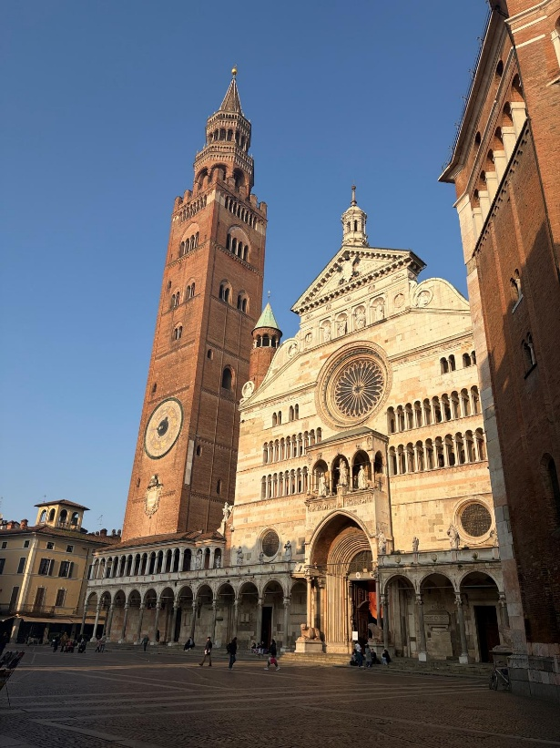

Torrazzo: Cremona Cathedral
AGENDA
Date: | May 19th, 2026  08.45 – 16.00
May 20th, 2026
09.00 – 12.45
Place: | Università Cattolica Del Sacro Cuore  Via Stefano Leonida Bissolati, 74, Campus Santa Monica  26100 Cremona CR, Italy

Day 1, Tuesday, 19th of May
 | Time | Topic | Speakers
 | 08.45 – 09.30 | Welcome and registration
AULA MAGNA | 09.30 – 09.50 | Welcome to the miGut meeting: Short speech from the coordinator | Prof. Andre Franke, Managing Director at the Institute of Clinical Molecular Biology, Christian-Albrechts-University of Kiel
AULA MAGNA |  | Welcome to UCSC: Opening words from the Dean of the Faculty of Psychology | Prof. Alessandro Antonietti, Dean of the Faculty of Psychology, Università Cattolica del Sacro Cuore
AULA MAGNA |  | Welcome to Cremona: Introduction of the EngageMinds HUB Consumer, Food & Health Engagement Research Center | Prof. Guendalina Graffigna, Director of the EngageMinds HUB Consumer, Food & Health Engagement Research Center, Università Cattolica del Sacro Cuore
AULA MAGNA |  | Welcome to the Italian IBD community: Introduction of AMICI Italia | Dr. Salvo Leone, CEO of AMICI Italia, Chairman at International Federation of Crohn's & Ulcerative Colitis Associations (IFCCA)
AULA MAGNA | 09.50 – 10.05  Online | How diet shapes the microbiota and reprograms the enteroendocrine system, Q&A | Prof. Antonio Gasbarrini, Scientific Director – Fondazione Policlinico Universitario Gemelli IRCCS, Full Professor of Internal Medicine – Università Cattolica del Sacro Cuore, Director – Department of Internal Medicine and Gastroenterology and CEMAD
AULA MAGNA | 10.05 – 10.30 | Unveiling unmet needs in IBD: creating a better future for patients, Q&A | MD. PhD. Cristina Bezzio, IBD Center, IRCCS Humanitas Research Hospital, Rozzano, Milan, Italy, Department of Biomedical Sciences, Humanitas University, Pieve Emanuele, Milan, Italy
 | 10.30 – 11.00 | Coffee break
AULA MAGNA | 11.00 – 11.25 | Metagenomics of the human microbiome to support precision nutrition strategies, Q&A | Prof. Nicola Segata, Principal Investigator at Department CIBIO, University of Trento
AULA MAGNA | 11.25 – 11.50 | The whole food Tasty&Healthy diet for treating and preventing Crohn’s disease – results from 4 clinical trials, Q&A | Prof. Dan Turner, Pediatric Gastroenterology, Shaare Zedek Medical Center, Jerusalem
AULA MAGNA | 11.50 – 12.15 | Fungi, key actors in One Health, Q&A | Prof. Paola Battilani, Full professor of Agri-Food Defense at the Faculty of Agricultural, Food, and Environmental Sciences, Università Cattolica del Sacro Cuore
AULA MAGNA | 12.15 – 12.30  Online | Self-compassion as a protective factor for stress and healthy behaviours in IBD, Q&A | Prof. Fuschia Sirois, Professor in the Department of Psychology, Director of Impact in the Department of Psychology, Durham University
AULA MAGNA | 12.30 – 12.45  Online | Psychological risk factors, maintaining good mental health, and psychological therapy in IBD, Q&A | Prof. Antonina Mikocka-Walus, Professor of Health Psychology and Deputy Head of School, School of Psychology, Deakin University
AULA MAGNA | 12.45 – 13.00 | Group photo
 | 13.00 – 14.00 | Lunch break
CLASSROOM B.0.01 | 14.00 – 15.15 | Inside miGut-Health: Scientific discoveries (presentation of the most important results/to be/published)
CLASSROOM B.0.01 | 15.15 – 16.00 | Round table: Future frontiers in IBD prevention – biomedical, nutritional, and psychological insights | Prof. Dan Turner, Prof. Philip Rosenstiel, Prof. Kostas Gerasimidis, Prof. Guendalina Graffigna, Prof. Marcel Salathé, Dr. Maria Stella de Rocchis  Moderated by: Prof. Guendalina Graffigna
CLASSROOM B.0.01 | 16.00 | End of the meeting – Day 1
 | 16.00 – 18.30 | Free time
 | 18.30 – 19.30 | Guided visit and exhibition in the Violin Museum (https://museodelviolino.org/it/)
 | 20.00 | Dinner at Palazzo Trecchi (https://www.palazzotrecchi.it/), for the project consortium and invited speakers

Day 2, Wednesday, 20th of May – Project-related activities
CLASSROOM B.0.01 | Time | Topic | Speakers
CLASSROOM B.0.01 | 09.00 – 09.15 | Management: Updates, main conclusions from the review report | Antonija Zrno Culap (RISE)
CLASSROOM B.0.01 | WP presentations (15 min presentation, 5 min Q&A)  WP 1-4 overview, including updates focusing on delays and missing parts
CLASSROOM B.0.01 | 9.15 – 9.35 | Work package 1 | UKSH
CLASSROOM B.0.01 | 9.35 – 9.55 | Work package 2 | UKE
CLASSROOM B.0.01 | 9.55 – 10.15 | Work package 3 | UKSH
CLASSROOM B.0.01 | 10.15 – 10.35 | Work package 4 | WEIZMANN
 | 10.35 – 11.00 | Coffee break
CLASSROOM B.0.01 | WP presentations (15 min presentation, 5 min Q&A)  WP 5-7 overview and updates
CLASSROOM B.0.01 | 11.00 – 11.20 | Work package 5 | UCSC, IFCCA
CLASSROOM B.0.01 | 11.20 – 11.40 | Work package 6 | UMCG
CLASSROOM B.0.01 | 11.40 – 12.00 | Work package 7 | Antonija Zrno Culap (RISE)
CLASSROOM B.0.01 | 12.00 – 12.45 | Open discussion: Looking forward - Final conference, project closing & potential continuation | All partners
CLASSROOM B.0.01 | 12.45 | End of the meeting – Day 2
 | 12.45 – 13.30 | Pocket lunch

